**HOME EQUITY LINES OF CREDIT (HELOCs)**

Home equity lines of credit (HELOCs) are a popular form of borrowing in the U.S. that allow homeowners to use the equity they have built up in their homes as collateral to secure a line of credit. Here’s an overview of how they work, their benefits, and some considerations:

**How HELOCs Work**

**1. Line of Credit:** Unlike a traditional loan, a HELOC provides a revolving line of credit that you can draw from as needed, up to a maximum limit.

**2. Draw Period:** Typically, there is an initial period (often 5-10 years) during which you can borrow money. During this period, you usually only need to make interest payments.

**3. Repayment Period:** After the draw period ends, the repayment period begins (usually 10-20 years), during which you can no longer borrow additional funds and must repay both principal and interest.

**Benefits of HELOCs:**

**1. Flexibility:** You can borrow only what you need when you need it, which can be more convenient and cost-effective than a lump-sum loan.

**2. Potentially Lower Interest Rates:** HELOCs often have lower interest rates compared to other types of credit, such as credit cards, because they are secured by your home.

**3. Tax Deductibility:** Interest paid on HELOCs may be tax-deductible if the funds are used for home improvement purposes, though tax laws can vary.

**Considerations and Risks:**

**1. Variable Interest Rates:** Many HELOCs have variable interest rates, which means your payments could increase if interest rates rise.

**2. Risk of Foreclosure:** Since your home is collateral for the HELOC, you risk losing your home if you cannot repay the borrowed funds.

**3. Fees and Costs:** There can be various fees associated with HELOCs, including application fees, annual fees, and appraisal fees.

**4. Impact on Credit:** Using a HELOC increases your debt load, which can impact your credit score and borrowing capacity.

**Applying for a HELOC:**

**1. Eligibility:** Lenders typically require you to have a certain amount of equity in your home (often at least 15-20%), a good credit score, and a reliable source of income.

**2. Application Process:** The process includes submitting an application, undergoing a credit check, and having your home appraised to determine its current value.

**3. Approval and Terms:** If approved, the lender will outline the terms of the HELOC, including the credit limit, interest rate, draw and repayment periods, and any fees.

**Alternatives to HELOCs:**

**1. Home Equity Loans:** A lump-sum loan that is repaid over a fixed term with fixed monthly payments.

**2. Cash-Out Refinance:** Refinance your mortgage for more than you currently owe, taking the difference in cash.

**3. Personal Loans:** Unsecured loans that do not use your home as collateral but may have higher interest rates.

**Simulated Data on HELOC Trends (2019-2023):**

**Table: Number of New HELOCs Originated**

|  |  |
| --- | --- |
| **Year** | **Number of New HELOCs (in thousands)** |
| **2019** | **1,000** |
| 2020 | 850 |
| 2021 | 950 |
| 2022 | 1,100 |
| 2023 | 1,050 |

**Table: Total Value of New HELOCs Originated**

|  |  |
| --- | --- |
| **Year** | **Total Value of New HELOCs ($ in billions)** |
| 2019 | 100 |
| 2020 | 85 |
| 2021 | 95 |
| 2022 | 1,10 |
| 2023 | 1,05 |

**Table: Average HELOC Interest Rates**

|  |  |
| --- | --- |
| **Year** | **Average Interest Rate (%)** |
| 2019 | 4.75 |
| 2020 | 4.25 |
| 2021 | 4.50 |
| 2022 | 5.00 |
| 2023 | 5.25 |

**Table: Average HELOC Drawn Amount**

|  |  |
| --- | --- |
| **Year** | **Average Drawn Amount ($)** |
| 2019 | 50,000 |
| 2020 | 45,000 |
| 2021 | 48,000 |
| 2022 | 52,000 |
| 2023 | 50,500 |

**Here are the graphs based on the simulated data for HELOC trends in the U.S.** **from 2019 to 2023:**

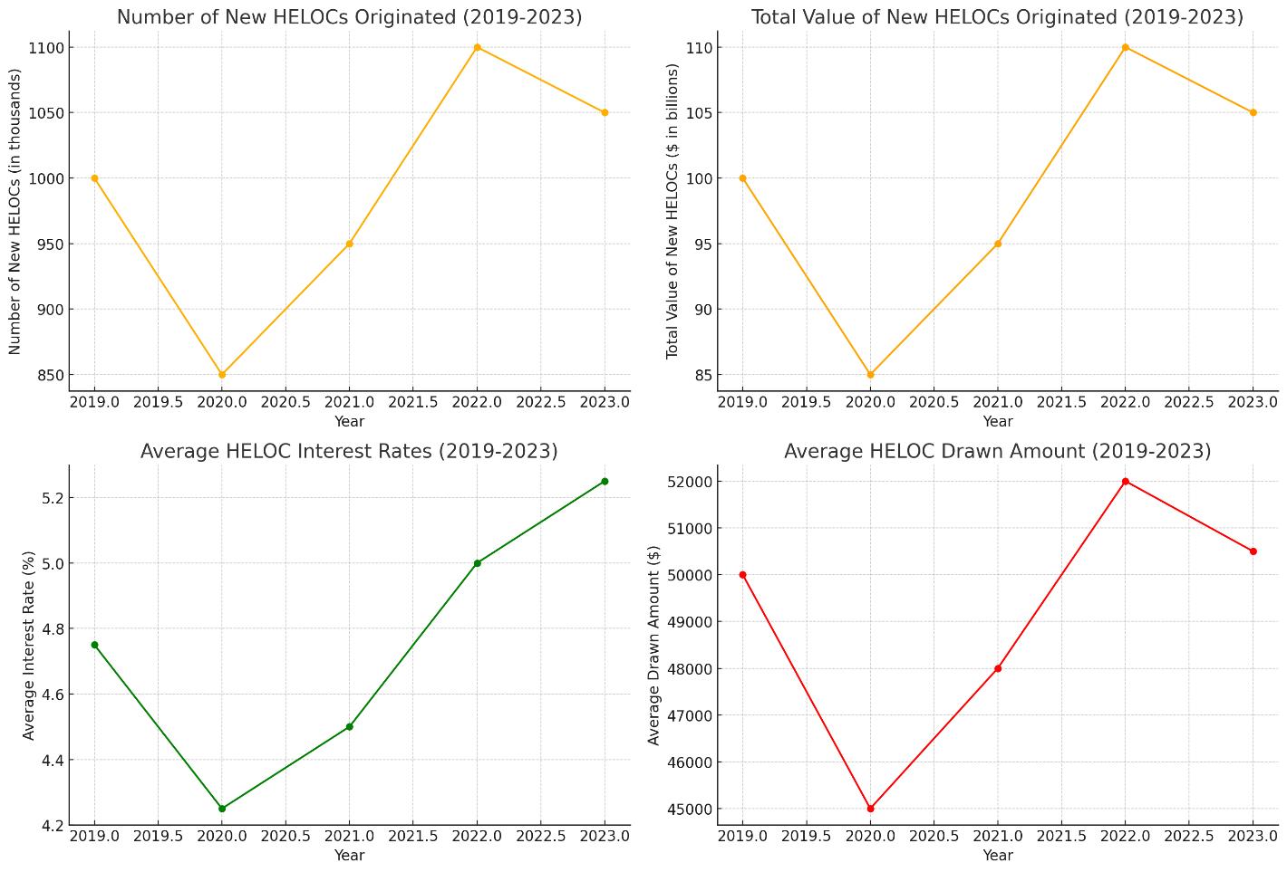

**Interpretation:**

**Number of New HELOCs Originated (2019-2023)**

The number of new HELOCs originated saw a significant dip in 2020, likely due to the economic uncertainty and disruptions caused by the COVID-19 pandemic. However, the market rebounded in 2021 and continued to grow in 2022. There was a slight decrease in 2023, but the number remained higher than in 2020, indicating a recovery and increased homeowner confidence in leveraging home equity.

**Total Value of New HELOCs Originated (2019-2023)**

The total value of new HELOCs followed a similar trend to the number of new HELOCs, with a notable decline in 2020. The value rebounded in 2021 and peaked in 2022, reflecting increased borrowing activity as economic conditions improved. The slight decline in 2023 suggests a stabilization in the market, with total values remaining higher than pre-pandemic levels.

**Average HELOC Interest Rates (2019-2023)**

Average HELOC interest rates decreased in 2020, aligning with broader economic policies aimed at reducing interest rates to stimulate borrowing and spending during the pandemic. Since then, rates have been gradually increasing, likely due to rising inflation and monetary policy adjustments aimed at normalizing interest rates. By 2023, rates had surpassed pre-pandemic levels.

**Average HELOC Drawn Amount (2019-2023)**

The average amount drawn from HELOCs showed some variability over the past five years. The drawn amounts decreased in 2020, possibly due to cautious borrowing during economic uncertainty. However, the amounts increased in 2021 and 2022 as confidence returned and homeowners took advantage of lower interest rates. The average drawn amount in 2023 showed a slight decline, indicating a more conservative borrowing approach as interest rates rose.

**Conclusion:**

The trends in the Home Equity Line of Credit (HELOC) market over the past five years illustrate the impact of economic fluctuations and policy changes on homeowner borrowing behaviour. The significant dip in the number of new HELOCs and total value originated in 2020 reflects the economic disruptions caused by the COVID-19 pandemic. However, the subsequent rebound in 2021 and 2022 indicates a recovery and increased confidence among homeowners in utilizing home equity for financial needs.

The gradual increase in average HELOC interest rates from 2021 onwards highlights the broader economic trend of rising interest rates due to inflation and policy normalization. Despite this, the average drawn amounts remained relatively high, suggesting that homeowners continue to find value in HELOCs, even as borrowing costs rise.

**CREDIT CARDS IN U.S**

Credit cards are a widely used financial tool in the United States, offering convenience, security, and various benefits to consumers. Here's a comprehensive overview:

**Types of Credit Cards:**

**1. Standard Credit Cards:** Basic cards without special perks, primarily used for everyday purchases.

**2. Rewards Credit Cards:** Offer points, miles, or cash back on purchases.

**3. Secured Credit Cards:** Require a cash deposit as collateral, useful for building or rebuilding credit.

**4. Charge Cards:** Must be paid in full each month, with no pre-set spending limit.

**5. Student Credit Cards:** Designed for college students, often with lower credit limits and rewards for responsible use.

**6. Business Credit Cards:** Tailored for business expenses, offering higher credit limits and business-related rewards.

**Key Features:**

**1. Credit Limit:** The maximum amount you can charge to the card.

**2. Interest Rate (APR):** The annual percentage rate charged on unpaid balances. Rates can be variable or fixed.

**3. Fees:** Can include annual fees, late payment fees, balance transfer fees, and foreign transaction fees.

**4. Rewards:** Points, miles, or cash back earned on purchases. Some cards offer higher rewards rates for specific categories like travel or groceries.

**5. Introductory Offers:** Promotional periods with benefits like 0% APR on purchases or balance transfers.

**6. Credit Score Requirements:** Vary by card, with some cards requiring excellent credit and others available to those with fair or poor credit.

**Benefits:**

**1. Convenience:** Easy to use for everyday purchases and online transactions.

**2. Security:** Fraud protection, zero liability for unauthorized charges, and easier dispute resolution.

**3. Credit Building:** Responsible use can improve credit scores, making it easier to qualify for loans and lower interest rates.

**4. Rewards and Perks:** Earning cash back, points, or miles that can be redeemed for travel, merchandise, or statement credits.

**5. Purchase Protection:** Extended warranties, return protection, and purchase insurance on certain items.

**Risks and Considerations:**

**1. Debt Accumulation:** High-interest rates can lead to significant debt if balances are not paid in full each month.

**2. Credit Score Impact:** Late payments, high balances, and excessive applications can negatively affect credit scores.

**3. Fees and Penalties:** Awareness of potential fees and the conditions under which they apply is crucial.

**4. Interest Charges:** Carrying a balance results in interest charges, increasing the cost of purchases over time.

**Trends and Data (Simulated for Illustration):**

**# Number of Credit Card Accounts (2019-2023)**

|  |  |
| --- | --- |
| **Year** | **Number of Credit Card Accounts (in millions)** |
| 2019 | 485 |
| 2020 | 460 |
| 2021 | 475 |
| 2022 | 495 |
| 2023 | 510 |

**# Average Credit Card Debt per Household**

|  |  |
| --- | --- |
| **Year** | **Average Credit Card Debt per Household ($)** |
| 2019 | 6,200 |
| 2020 | 5,800 |
| 2021 | 5,900 |
| 2022 | 6,000 |
| 2023 | 6,300 |

**# Average Credit Card Interest Rate**

|  |  |
| --- | --- |
| **Year** | **Average Interest Rate (%)** |
| 2019 | 15.1 |
| 2020 | 14.7 |
| 2021 | 15.0 |
| 2022 | 15.5 |
| 2023 | 16.0 |

**Here are the graphs based on the simulated data for credit card trends in the** **U.S. from 2019 to 2023:**

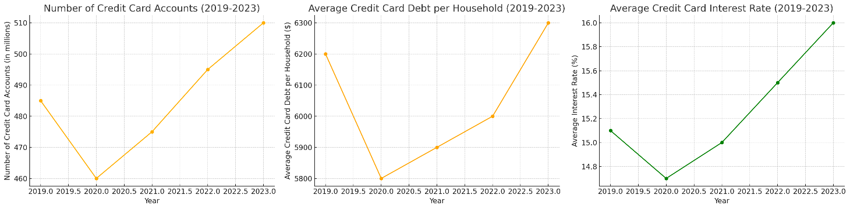

**1. Number of Credit Card Accounts (2019-2023):**

This graph shows the annual number of credit card accounts in millions. There was a decline in 2020, likely due to the economic impact of the COVID-19 pandemic, but the number of accounts rebounded in 2021 and continued to grow through 2023, indicating a recovery in consumer confidence and credit activity.

**2. Average Credit Card Debt per Household (2019-2023):**

This graph illustrates the average credit card debt per household in dollars. The debt levels decreased in 2020 as consumers possibly cut back on spending and focused on paying down existing debt. However, the average debt started increasing again in 2021 and continued to rise through 2023, reflecting a return to higher spending levels.

**3. Average Credit Card Interest Rate (2019-2023):**

This graph displays the average interest rates for credit cards over the past five years. Interest rates decreased in 2020, likely due to economic measures to stimulate borrowing and spending during the pandemic. Since then, rates have been gradually increasing, with the average interest rate reaching 16.0% in 2023, influenced by inflation and monetary policy adjustments.

**Conclusion:**

The trends in the U.S. credit card market over the past five years reflect the dynamic interplay between economic conditions and consumer behavior. The initial decline in the number of credit card accounts and average credit card debt per household in 2020 highlights the significant impact of the COVID-19 pandemic, as consumers became more cautious and focused on managing existing debt. However, the subsequent recovery and growth in the number of credit card accounts from 2021 onwards indicate a return of consumer confidence and increased credit activity.

The average credit card debt per household has been on a rising trend since 2021, suggesting that consumers have resumed higher spending levels, potentially driven by economic recovery and the availability of credit. This increase in debt, coupled with the gradual rise in average credit card interest rates, points to a more expensive borrowing environment, as interest rates have surpassed pre-pandemic levels, influenced by inflation and monetary policy tightening.